GROUP ASSIGNMENT
TECHNOLOGY PARK MALAYSIA
CT124-3-2-MAE
MOBILE APP ENGINEERING
INTAKE CODE: APD2F2511CS/APU2F2511CS
ASSIGNMENT HAND OUT DATE: 14th May 2026
ASSIGNMENT HAND IN DATE: 21st June 2026
LECTURER: MR. AMAD ARSHAD
Student Details:
No. | Name | TP Number
1. | Choong Ti Huai | TP078539
2. | Liu Wei | TP085412
3. | Gao Xing | TP085905

Table of Contents
Abstract 1
1.0 Introduction 2
2.0 Related Work 3
3.0 Motivation 5
4.0 Project Description 6
4.1 Key Use Cases for Each User Role 6
4.2 Design Strategies 7
4.3 MVP Feature Modules 8
4.4 Technical Requirements 9
4.5 Adoption and cold-start strategy 11
5.0 Tasks and Milestones 13
5.1 Key Milestones 13
5.2 Workload Allocation 14
6.0 References 15
7.0 Appendix 16
7.1 Appendix A: Informed Consent Script 16
7.2 Appendix B: Interview Guide 16
7.3 Appendix C: Photo and Recording Checklist 17
7.4 Appendix D: Image Handling and Anonymisation Notes 18

Abstract
Builder Plaza is a proposed cross-platform mobile application that helps people who build, maintain, design, evaluate, or hire for software projects find credible collaborators and decide whom to contact. Today this trust is split across disconnected tools: GitHub is read as proof of technical work, LinkedIn as proof of professional identity, and scattered channels such as Discord, Product Hunt and hiring platforms as weak signals of availability, yet none of them shows whether a person is actually open to collaboration right now. This report documents a generative research study built on contextual interviews and field observation with five participants representing distinct user roles: an indie builder, an open-source maintainer, a non-technical product designer, an AI-agent–native builder, and a startup CTO. It presents the research questions, methodology, ethics and protocol, one-page participant profiles, a three-level affinity analysis (verbatim evidence → first-person notes → declarative behaviour statements), and design ideas grounded directly in that data. The strongest unmet need is a structured layer that connects identity, proof of work, current intent, and safe communication. The foundation the Builder Plaza concept is designed to provide.

1.0 Introduction
Modern software is built by a distributed, loosely connected population of makers: indie builders shipping side products, open-source maintainers carrying critical packages, designers and product generalists looking for technical partners, AI-agent-native developers, and technical decision-makers who hire and shortlist talent (GitHub, n.d.). For all of them, finding the right collaborator at the right moment is a recurring, high-friction problem.
The trust required to begin a collaboration is currently split across disconnected platforms. GitHub demonstrates proof of technical work; LinkedIn demonstrates professional identity; Discord, Product Hunt and hiring platforms expose only fragments of availability (GitHub, n.d.) (LinkedIn, 2025) (Y Combinator, n.d.). No single tool answers the decisive question a builder actually asks: “is this person credible, currently open to collaborate, and safe to contact in this specific context?” Builder Plaza is proposed as a cross-platform mobile application that unifies these signals into one structured layer: verified proof of work, professional identity, current collaboration intent, and safe, contextual contact.

2.0 Related Work
The software-collaboration landscape is shifting from solitary human coding toward human-machine and multi-agent collaboration, in which builders increasingly work alongside AI coding agents such as GitHub Copilot, Cursor and Kilo Code (Cursor, n.d.) (Kilo Code, n.d.) (GitHub Copilot, n.d.). Existing developer-social and founder-matching platforms were not designed for this transition, and each covers only part of the problem. GitHub and LinkedIn remain the default pair: proof of work and professional identity, yet neither is primarily designed to match collaborators by current project intent. GitHub exposes technical activity through repositories, commits and pull requests, while LinkedIn’s self-serve sign-in product is mainly based on OpenID Connect identity information rather than unrestricted profile access (GitHub, n.d.) (LinkedIn, 2025). YC Co-Founder Matching uses manual question-and-answer screening with mutual-intent chat, but enforces no dual verification, so it is plagued by development-shop spam and GPT-fabricated profiles and often degenerates into an “unpaid employee search (Y Combinator, n.d.).” StartuPage verifies founders through Stripe revenue and business data, but its barrier is too high for early-stage or open-source builders (StartuPage, n.d.).
Across these tools a consistent gap emerges: none simultaneously solves trust / anti-fraud and efficient matching. Platforms strong on verification are too narrow or manual, while those strong on agent-native interaction lose real human and business value. The unmet space, summarised in Table 1, is a vertical platform that fuses verified code assets (GitHub) with verified professional identity (LinkedIn), uses the live “product-in-progress” as the social medium, and supports safe, agent-assisted matching. Builder Plaza is designed to occupy exactly this gap.
Platform | Identity verification | Matching / social model | Agent-era fit | Core limitation
GitHub | Account only (no identity proof) | Repos, issues, stars — no matching | N/A (code host) | Shows activity, not intent or identity; hard for non-technical users
LinkedIn | Self-declared profile | Professional feed, recruiter search | Low | Hiring-oriented, inflated claims, restricted API, no proof of work
Moltbook | X account; agents only | Reddit-style agent forum (Submolts) | Very high (agent-native) | No human business value; LLM “hallucination spam”; API-key leak
Peerlist | LinkedIn SSO + GitHub | Composable résumé, jobs / recruiting | Medium (Web 2.5) | No real-time product plaza or agent-native access
YC Co-Founder Matching | Manual review; optional LinkedIn | Q&A screening, mutual-intent chat | Low (manual) | Dev-shop spam, GPT-faked profiles; “unpaid employee search”
StartuPage | Stripe revenue + LinkedIn | Real-business-data (MRR) dashboard | Low (business-only) | Barrier too high; excludes early-stage / open-source builders
Builder Plaza (proposed) | Forced GitHub + LinkedIn dual verification | “Product-in-progress” growth plaza + Bayesian matching | High (A2A / MCP, human-in-the-loop) | Fills the gap: verified, intent-aware, safe, agent-assisted

3.0 Motivation
The motivation for Builder Plaza is grounded directly in the generative study reported here. Across five participants in deliberately different roles, the same unmet need recurred: a trusted, low-noise way to evaluate real work, express what one is currently open to, and initiate contact with context. Each role feels a different edge of the same problem: for the indie builder, cold direct messages are inefficient and current intent is invisible; for the maintainer, stars and followers do not translate into maintenance help; for the non-technical designer, GitHub is a “black box”; for the agent-native builder, AI-generated projects create noise and unsafe scripts create risk; and for the CTO, inflated CVs and fragmented signals make shortlisting expensive.
The timing is significant. AI coding tools have multiplied the number of projects each person can produce, as one participant put it, “after AI coding, everyone has five projects, but I don't know which ones are real.” This simultaneously raises productivity and noise, making verified, recent, genuine activity and human-controlled, safe contact more valuable than ever. The opportunity is therefore not to build another social feed, but to build a structured trust-and-intent layer.
Builder Plaza's distinctive answer to this noise is forced dual verification. By auditing genuine GitHub signals: commit history, repository age, pull-request merge frequency, unit-test coverage and originality rather than raw star counts, and binding them to an enterprise-verified LinkedIn identity, the platform aims to filter out the GPT-packaged intermediaries and outsourcing “lead-scrapers” that pollute existing tools, and to return discovery to authentic build-in-public makers. This study translates that opportunity into concrete, evidence-grounded features: Project Cards, Intent Badges, Match Reason, Controlled DM, a Maintainer Request Market, plain-language credibility summaries, safe sandboxed demos, and human-approved agent contact, which the remainder of this report develops and justifies.

4.0 Project Description
Builder Plaza is a cross-platform mobile application, built with Flutter for iOS and Android, that connects builders, maintainers, collaborators and opportunity providers around verified work, current intent and safe contact. The system supports the five user roles derived from the participant personas and turns the affinity findings into a coherent product.

4.1 Key Use Cases for Each User Role
Figure below presents the use case diagram, showing how each role and external system interacts with Builder Plaza. The primary use cases for each role are summarised in table below.
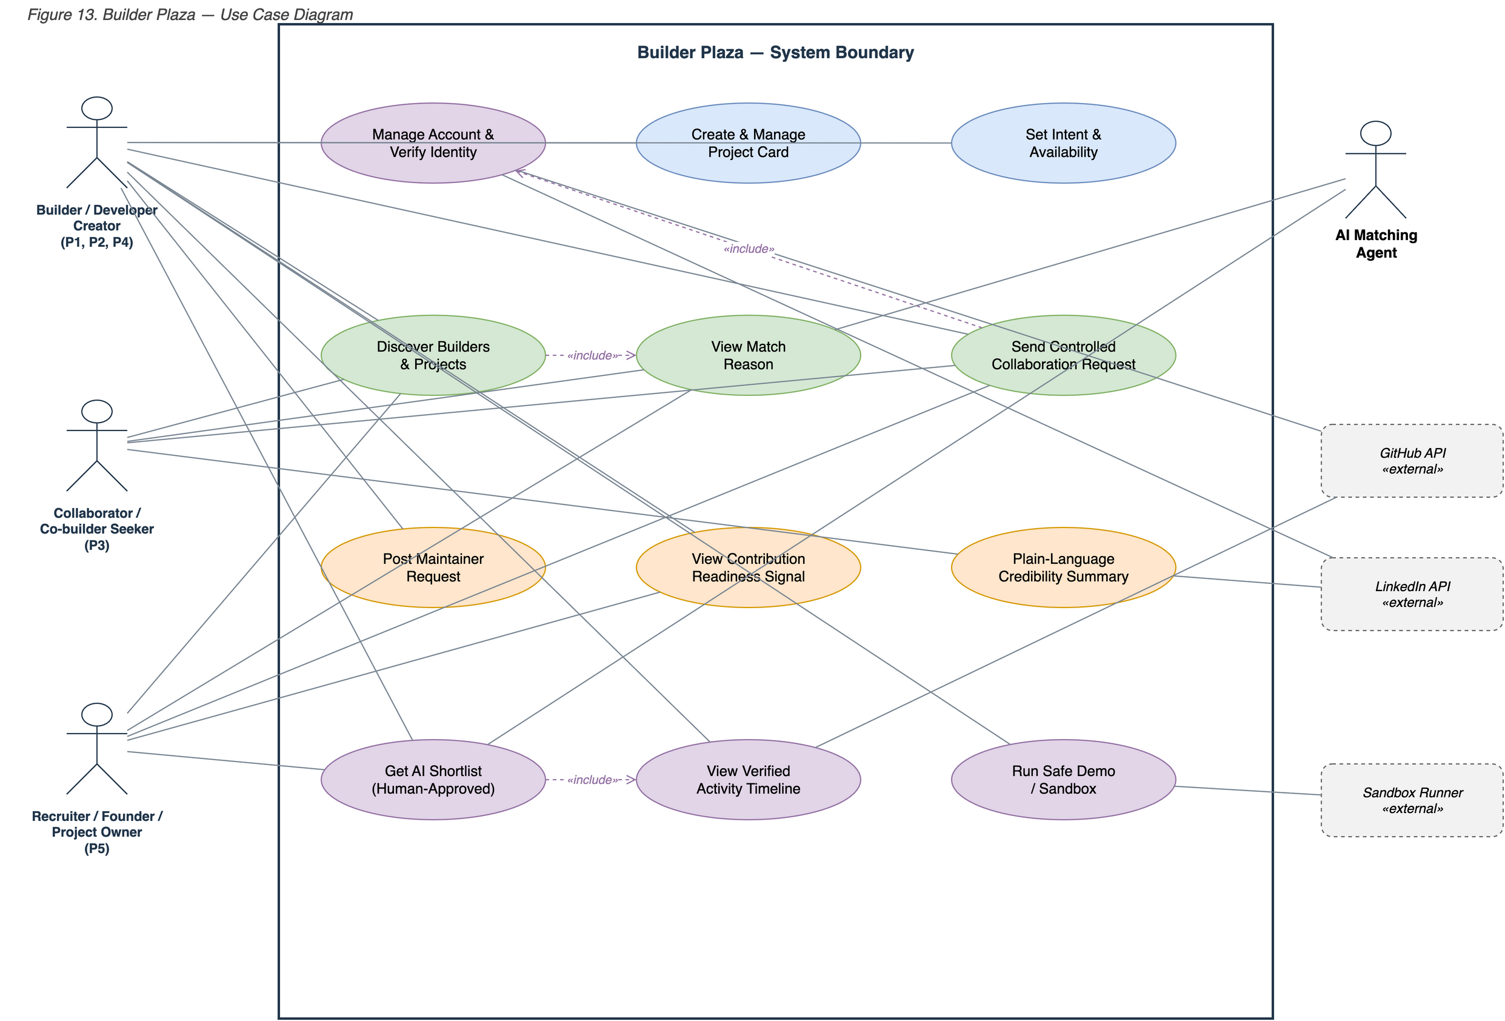
Figure 1 Use Case Diagram

User Role | Key Use Cases
Builder / Developer (PI, P2, P4) | - Create & Manage Project Card  - Set Intent & Availability  - Discover Collaborators  - Send a Controlled Collaboration Request  - Post a Maintainer Request  - Request an AI shortlist (human-approved)  - View a Verified Activity Timeline  - Run a Safe Demo Inside a Sandbox
Collaborator / Co-builder Seeker (P3) | - Discover Builders & Projects  - View a plain-language credibility summary;  - View the Match Reason  - Initiate Contextual Contact
Recruiter / Founder / Project Owner (P5) | - Discover & Shortlist Builders  - View the Match Reason  - Review Project-ownership Evidence  - Send a Structured Collaboration Request

4.2 Design Strategies
- Evidence-first, not claim-first — surface verified activity (commits, releases, pull requests) ahead of self-description.
- Intent-explicit — make “what I am open to right now” a first-class, visible field rather than a hidden assumption.
- Low-noise, explainable matching — offer fewer, better matches, each accompanied by a visible reason.
- Role-adaptive translation — present the same technical evidence in plain language for non-technical users.
- Safe, staged collaboration — progress from claim-an-issue to limited access to full access; sandbox demos; human-approved agent contact.
- Privacy and anonymity by design — anonymised profiles, controlled contact, and no exposure of raw contact details.

4.3 MVP Feature Modules
Translating these strategies into a buildable system, the minimum viable product is organised around four modules under the core philosophy of “verification is trust, building is content, the agent mediates the match,” summarised in table below.
Module | Core logic | Key technology | Agent-era feature
Dual-Source Trust Gateway | Force GitHub + LinkedIn dual-binding before a profile can be created | GitHub OAuth (GraphQL code portrait) + LinkedIn SSO | Local validation agent audits repositories, filtering script-faked stars and zombie commits
Dynamic Growth Plaza | “Build = publish”: generate updates from code activity, removing the marketing burden | GitHub Webhooks (commit / PR / release) refined by a lightweight LLM into “product growth” cards | Third-party AI-ops agents may connect via MCP to summarise project growth
Bayesian Matching Matrix | Match complementary tech stacks and business needs instead of swiping | Gaussian-process regression over GitHub code vectors and LinkedIn business vectors (80% exploit / 20% explore) | Agent-to-Agent (A2A) discovery lets a builder's own agent pre-screen candidates
Trust Score Engine | Keep out intermediaries, non-technical “freeloaders” and AI spam | GitHub contribution index + LinkedIn tenure + Stripe revenue badge + in-platform peer review | Proof-of-Work challenge that external agents must pass to act — anti-Sybil protection
To balance exposure and privacy, a profile stays hidden in the plaza below 40% completeness and unlocks full matching at 70% or above; if a user's GitHub activity or LinkedIn identity shows abnormal fluctuation, the trust score temporarily lowers their display weight until re-verification. Matching itself avoids “dating-style” swiping: a Gaussian-process recommender fits each builder's GitHub code vector against their LinkedIn business-need vector, returning 80% strongly-aligned matches and 20% exploratory ones to spark cross-domain collaboration.

4.4 Technical Requirements
Builder Plaza follows the three-tier architecture in figure below: a Flutter client tier; an application-and-services tier exposing the dual-source trust gateway, growth-plaza service, validation agent, Bayesian matching engine and trust-score engine; and a data tier built on PostgreSQL, a vector store of de-privatised skill embeddings, and object storage for binary media (Flutter - Build apps for any screen, n.d.) (About PostgreSQL, n.d.). The client communicates over HTTPS/REST (JSON); the trust gateway and validation agent integrate with the GitHub and LinkedIn APIs to establish proof of work and identity, while untrusted demo code is confined to a WebAssembly sandbox.
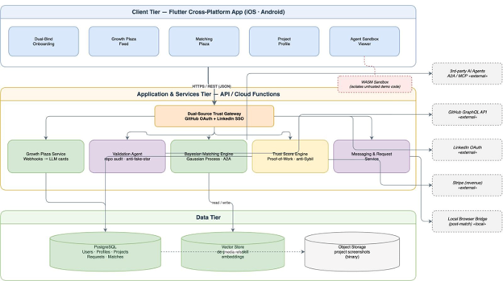
Figure 2 System Architecture Diagram
The core data manipulations are standard create, read, update and delete (CRUD) operations over the entities listed in table below. Structured records are held in PostgreSQL, de-privatised skill features in a vector store, and image-based binary data: anonymised profile photos and project screenshots, in object storage. Third-party data APIs supply the trust signals: the GitHub GraphQL API verifies recent activity and proof of work, LinkedIn OAuth (with on-the-fly rendering) establishes professional identity, and Stripe revenue badges corroborate commercial traction.
Core entity | Create | Read | Update | Delete | Primary role
User / Profile | Sign-up & verify | View profile | Edit / re-verify | Deactivate | All
Project Card | Author card | Browse / discover | Update stage & needs | Archive | Builder / Maintainer
Intent & Availability | Set status | Shown on profile | Change status | Clear | All
Collaboration Request | Send request | View inbox | Accept / decline | Withdraw | All
Maintainer Request | Post role | Browse market | Edit / close | Delete | Maintainer
Match / Shortlist | System-generated | View + reason | Refine filters | Dismiss | System · CTO · Builder
Two external constraints shape the design. First, compliance: LinkedIn's API (tightened for 2026) permits only Sign-In-with-LinkedIn (OAuth 2.0) and forbids unauthorised automated messaging, and member data may be cached only briefly (24 - 48 hours). Builder Plaza therefore renders LinkedIn data on the fly at sign-in rather than persisting a public-résumé database, stores only de-privatised skill embeddings, and performs any post-match LinkedIn outreach through a user-local browser bridge rather than a cloud API. Second, agent safety: because autonomous agents such as Claude Code and Cursor hold broad local read and write access, and empirical studies report that roughly one third of agents in open agent-social networks leak their owner's private context, Builder Plaza isolates all untrusted demo code in a WebAssembly (WASM) sandbox, never runs third-party code in a user's browser or local agent console, and gates agent participation behind a Proof-of-Work challenge to protect the localhost trust boundary.
Other non-functional requirements follow from the study: least-privilege and staged access, privacy and anonymity, explainability of every recommendation, responsive cross-platform performance from a single Flutter codebase, and tolerance of intermittent connectivity for read operations.

4.5 Adoption and cold-start strategy
Because the platform's value depends on network effects and its dual-verification barrier is deliberately high, adoption follows a focused cold-start plan. The first phase seeds the two highest-purity builder subcultures: “indie hackers” and “build-in-public”, through precise outreach on r/buildinpublic, r/SideProject and Hacker News, under a manifesto of “find real code builders, reject outsourcing fraud.” The second phase launches a “Verified Early Builder” badge for makers with high-signal GitHub repositories (for example, 500+ stars) and verifiable enterprise tenure on LinkedIn, granting them priority visibility so the platform establishes a high-trust character before opening more broadly (Katz, 1985) (Hacker News, n.d.).

5.0 Tasks and Milestones
The project runs across the semester (May–August 2026) in two phases: Part 1, the generative research and project proposal, due in the middle of the semester (22 June 2026); and Part 2, the system build, automated testing and app demo, due at the end of the semester. Figure below shows the full schedule as a Gantt chart, with task durations, owners and milestones; the dashed marker indicates the current date (21 June 2026), at which the proposal phase is being completed.
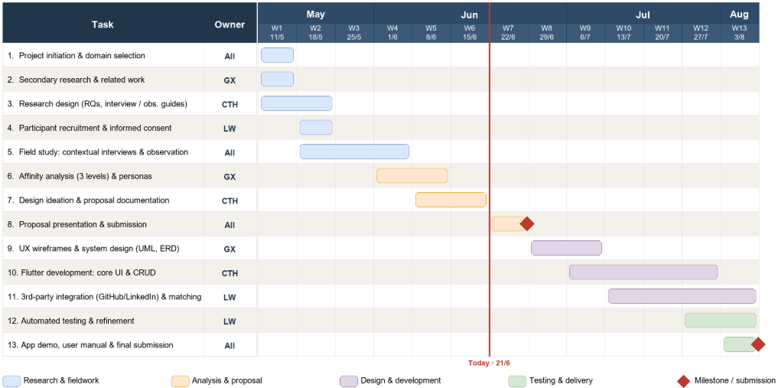
Figure 3 Gantt Chart

5.1 Key Milestones
M1 — Research instruments and participant consent ready (Week 2, ~18 May 2026).
M2 — Field study complete; raw quotes and observations collected (Week 4, ~1 June 2026).
M3 — Three-level affinity analysis and personas complete (Week 5, ~8 June 2026).
M4 — Generative research and project proposal submitted (Week 7, 21 June 2026).
M5 — System design (wireframes, architecture, ERD) approved (Week 8, ~29 June 2026).
M6 — Core Flutter application with CRUD functional (Week 9, ~6 July 2026).
M7 — Third-party integration and matching complete; automated testing done (Week 10, ~13 July 2026).
M8 — Final artifact, report, user manual and recorded demo submitted (Week 13, ~3 August 2026).

5.2 Workload Allocation
Member (TP number) | Adopted user roles
Choong Ti Huai (TP078539) | Founder
Liu Wei (TP085412) | Builder
Gao Xing (TP085905) | Collaborator

6.0 References
About PostgreSQL. (n.d.). Retrieved from PostgreSQL: https://www.postgresql.org/about/
Cursor. (n.d.). Cursor: The AI code editor. Retrieved from Cursor: https://cursor.com/
Flutter - Build apps for any screen. (n.d.). Retrieved from Flutter: https://flutter.dev/
Flutter - Build apps for any screen. (n.d.). Retrieved from Flutter: https://flutter.dev/
GitHub Copilot. (n.d.). Retrieved from GitHub: https://github.com/features/copilot
GitHub. (n.d.). GitHub Copilot documentation. Retrieved from GitHub Docs: https://docs.github.com/copilot
GitHub. (n.d.). GitHub REST API documentation. Retrieved from GitHub Docs: https://docs.github.com/en/rest
GitHub. (n.d.). GitHub: Let’s build from here. Retrieved from GitHub: https://github.com/
Hacker News. (n.d.). Hacker News. Retrieved from Y Combinator: https://news.ycombinator.com/
Katz, M. L. (1985). Network Externalities, Competition, and Compatibility. The American Economic Review, 424-440.
Kilo Code. (n.d.). Kilo Code. Retrieved from Kilo Code: https://kilocode.ai/
LinkedIn. (2025, 2 4). Sign in with LinkedIn using OpenID Connect. Retrieved from Microsoft Learn: https://learn.microsoft.com/en-us/linkedin/consumer/integrations/self-serve/sign-in-with-linkedin-v2
r/buildinpublic. (n.d.). Retrieved from Reddit: https://www.reddit.com/r/buildinpublic/
StartuPage. (n.d.). Stripe Integration for Startups. Retrieved from StartuPage: https://startupa.ge/integrations/stripe
Y Combinator. (n.d.). Co-Founder Matching Platform. Retrieved from Y Combinator: https://www.ycombinator.com/cofounder-matching
Y Combinator. (n.d.). Co-Founder Matching Platform. Retrieved from Y Combinator: https://www.ycombinator.com/cofounder-matching

7.0 Appendix

7.1 Appendix A: Informed Consent Script
You are invited to participate in a class research study about how people find and evaluate collaborators for software and product-building projects. The session will include questions about your recent experiences and, if you agree, a walkthrough of the tools or platforms you normally use.
Your participation is voluntary. You may stop at any time or skip any question. There are no anticipated risks beyond ordinary discussion of your work practices. Your name will be anonymized in the report, and any screenshots or photos will be blurred or edited to remove private information. If we record audio, video, or photos, we will ask your permission first and use the recording only for this class project.
Do you consent to participate in this study? Do you consent to audio recording? Do you consent to a participant or environment photo being used in anonymized form?

7.2 Appendix B: Interview Guide
1. What kind of builder, collaborator, contributor, tester, or technical partner have you recently tried to find?
2. Where did you look first? Why did you choose that platform?
3. What made someone seem credible or not credible?
4. What project evidence did you check?
5. What signals did you ignore or distrust?
6. What information was missing when you decided whether to contact someone?
7. What makes cold messaging difficult or uncomfortable?
8. How do you decide whether a project is real and active?
9. What would a platform need to show for you to trust a recommended match?
10. What safety controls would you need before testing a project, giving repository access, or letting an AI agent help you match?

7.3 Appendix C: Photo and Recording Checklist
Participant | Participant photo inserted? | Environment photo inserted? | Blur/anonymize required? | Audio/recording note
P1 Ryan Tan | Inserted — blurred | Context blurred in card | Yes — anonymised | Synthetic photo; no audio shared
P2 Aisha Rahman | Inserted — blurred | Context blurred in card | Yes — anonymised | Synthetic photo; no audio shared
P3 Mei Chen | Inserted — blurred | Context blurred in card | Yes — anonymised | Synthetic photo; no audio shared
P4 Daniel Wong | Inserted — blurred | Context blurred in card | Yes — anonymised | Synthetic photo; no audio shared
P5 Marcus Lee | Inserted — blurred | Context blurred in card | Yes — anonymised | Synthetic photo; no audio shared
R1 Ivan Wang | Inserted — blurred | Context blurred in card | Yes — anonymised | Synthetic photo; no audio shared
R2 Dylan Park | Inserted — blurred | Context blurred in card | Yes — anonymised | Synthetic photo; no audio shared
R3 Chen Yu | Inserted — blurred | Context blurred in card | Yes — anonymised | Synthetic photo; no audio shared
S1 Tan Ee Heng | Inserted — blurred | Context blurred in card | Yes — anonymised | Synthetic photo; no audio shared
S2 Sophia Lin | Inserted — blurred | Context blurred in card | Yes — anonymised | Synthetic photo; no audio shared
S3 Claire Wu | Inserted — blurred | Context blurred in card | Yes — anonymised | Synthetic photo; no audio shared

7.4 Appendix D: Image Handling and Anonymisation Notes
- All eleven participant photographs are synthetic and blurred; no real person is depicted.
- Faces and any on-screen content: private screens, account names, repository names, dashboards, messages and contact details, are blurred or cropped so that no identifying information is visible.
- Each profile photo appears inside a one-page persona card carrying an explicit “Anonymised” marker.
- Captions describe what each image shows and the participant’s role, not any real identity.
- Where a participant requested full anonymity, the photo is an anonymised environment image rather than a personal photo.

